1️⃣ Competitive Markets
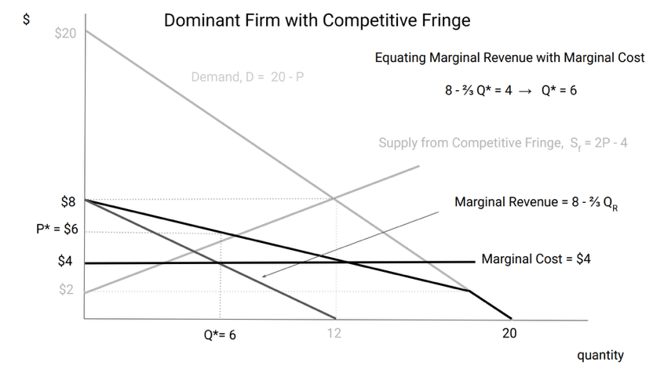
Definition: Identical products/All firms are price takers
Short Run: Capital fixed/ P determined by intersection of supply & demand/ Prices can exceed MC due to capacity constraints/ Price volatility ≠ market power
Long Run: Entry & exit adjust/P = MC = ATC/Efficient equilibrium
2.Market Power= ability to raise price by restricting quantity, Competitive market: Firm reduces quantity → no price effect; Non-competitive: Firm reduces quantity → price increases
3️⃣ Monopoly: MR=MC → Q → demand 找 P
Total Revenue
𝑇𝑅(𝑄)=𝑃(𝑄)⋅𝑄TR(Q)=P(Q)⋅Q
Marginal Revenue
𝑀𝑅(𝑄)=𝑃(𝑄)+𝑃′(𝑄)𝑄MR(Q)=P(Q)+P′(Q)Q
For linear demand:
𝑃=𝑎−𝑏𝑄P=a−bQ𝑀𝑅=𝑎−2𝑏𝑄MR=a−2bQ
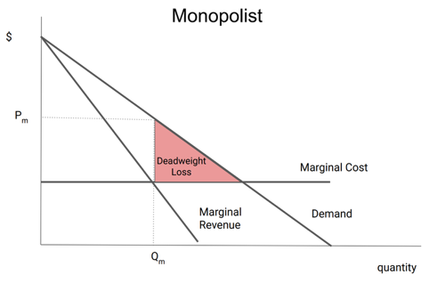
Profit Maximization
𝑀𝑅=𝑀𝐶
Monopolist: Produces lower Q/Sets higher P/Create deadweight loss
4️⃣ Dominant Firm + Competitive Fringe
Residual demand: 𝑄𝑟=𝑄𝑑−𝑄𝑓 (market demand – fringe supply), MR 是 inverse residual demand 斜率加倍
Dominant firm treats residual demand like a monopolist treats demand. The more inelastic residual demand, the more scope for market power. Market power strongest when: 1. Market demand is inelastic 2. Fringe supply is inelastic

5️⃣ Auctions
Uniform price auction: 1.All winners receive clearing price 2.Competitive firms bid ≈ MC
Pay-as-bid: 1. Must forecast clearing price 2. Harder to bid optimally 3. Competitive firms bid ≈ expected clearing price (bids inflated, so if demand decreses, price won’t change too much as uniform does)
Winner’s Curse: 1. Common value auctions 2.More bidders → more likely someone overestimates
6️⃣ Futures Markets
Futures: Exchange traded/Standardized/Mark-to-market/Clearinghouse reduces counterparty risk/high liquidity/ low transaction costs
Forwards: OTC(over the counter private contract)/Customized/Higher counterparty risk/Lower basic risk/low liquidity
Basic

7️⃣ Hedging
If future exposure = buying a commodity: Hedge with long futures. If future exposure = selling a commodity: Hedge with short futures
Cross hedge principle: 𝐻𝑒𝑑𝑔𝑒 𝑆𝑖𝑧𝑒=𝐸𝑥𝑝𝑜𝑠𝑢𝑟𝑒×𝑃𝑟𝑖𝑐𝑒 𝑆𝑒𝑛𝑠𝑖𝑡𝑖𝑣𝑖𝑡𝑦 風險係數 × 用量 = 需要的期貨數量；怕漲價 → buy, 怕跌價 → sell
8️⃣ Storage Economics
Carry cost includes: 1.Interest rate 2. Storage cost
Higher interest rate → lower storage incentive
Contango: Futures price > Spot → store more, Backwardation: Futures price < Spot → store less
Storage reduces price volatility across time.

9️⃣ Transportation
If:
𝑃2−𝑃1>𝑀𝐶𝑡𝑟𝑎𝑛𝑠𝑝𝑜𝑟𝑡. → Arbitrage occurs
Transportation equalizes prices (net of cost).
If transporter has market power:
→ Price wedge too large
→ Deadweight loss

